Using the Electra One Continuum Controller Application

Version 2.0.2
August 23, 2026
Richard Kram, Simon O’Rorke

Contents
What's New in Version 2.0.2 2
What's New in Version 2.0 2
Overview 2
Version Compatibility 3
Connecting the Electra One to the Haken Continuum 4
On Booting the Electra One Loaded with Continuum Controller 4
Electra One Controller Navigation 5
Continuum Controller Pages 5
Main Performance – Presets and Macros Page 7
Loading Presets 8
Selecting Presets 9
Storing presets 10
Clearing presets 11
Effects/Pedals Page 12
Gain and Convolution Page 14
Transposition Page 16
Rounding and Tuning Page 18
Info Page 20
Installing the Continuum Controller Application 21
When to use the Haken Editor 22
Support and Feedback 22

Note: We make no guarantees as to the correctness or operation of this software application. You run it at your own risk. It may appear to malfunction if you have the Haken Editor running at the same time.

What's New in Version 2.0.2

For display on E1 buttons, added more short names for system presets with names longer than 14 characters. The short system preset names are now up to date as at firmware version 10.77.

Fixed firmware version 10.77 compatibility issues.

What's New in Version 2.0

The Electra One preset named "Continuum Controller" supersedes presets Continuum Ctrl 10.52 and EMM Ctrl 10.52. Previous versions of the Electra One preset were specific to a Haken Audio firmware version and to either Continuum or EaganMatrix Eurorack module (EMM) hardware.

All Haken Audio firmware versions from 10.44 and both types of hardware instrument are now supported.
- This is possible because the list of system presets is refreshed from the instrument when the firmware version or hardware type changes

To make browsing the system preset list to load presets easier, the Selected Category and System Preset Number controls indicate the currently or most recently loaded system preset, instead of being reset to no selection when a system preset is loaded.

To make saving a preset to a user preset slot easier, when a user preset is loaded, the Store User Position control's value is set to the position of the loaded preset.

Automatically receiving preset lists from the instrument on loading Continuum Controller is no longer supported. as this could cause some Electra Ones to get stuck on the splash screen, preventing Continuum Controller's load from completing.

Bug fixes.

Overview

The Electra One Continuum Controller is a stand-alone controller for Haken Slim Continuum, EaganMatrix Eurorack Module (EMM), and also older “Thick” Continuums with at least at least 2x DSP.

The Continuum Controller is meant to perform a number of functions that the editor supports, but does not replace the editor as it cannot be used to program/edit presets. It is intended to be used in a stand-alone controller mode (that is it does not interface with the Haken editor and it does not sync with the Continuum such that if you change a preset that changes on the Controller, though if you change a preset with the controller it should map the current Macros and other settings for that preset correctly.

Note: The Continuum Controller should never be used with the editor. It is only intended to be used as a controller when you don’t want to use the editor.

It is suggested that you have the Continuum User’s Guide handy when reading this document if you need further details on any of the features that are summarized for this manual.

Continuum Controller is not a Haken Audio product. Please do not raise Haken Audio tickets.

Version Compatibility

Electra One

The current version of the Electra One Continuum Controller requires the following Electra One hardware and firmware versions:

- Hardware: Mk II (It will not run on Mk1 models.)
- Firmware: 4.0 or later

Haken Audio Firmware

Connected instruments must be running Haken Audio firmware 10.44 or later.

Haken Continuums

The controller has been verified to operate on all Slim Continuum and at least 2x DSP Thick Continuums as well as EaganMatrix Module. (1x DSP Continuum cannot run the minimum required Haken Audio firmware version.)

EaganMatrix Eurorack Module:

The Electra One Continuum Controller supports the EaganMatrix module (EMM).

ContinuuMini/EaganMatrix Micro:

Currently Not Supported.

Osmose: (See Separate Osmose Controller)

A separate Osmose EL1 Controller is available for Osmose 2.1.21/10.52 firmware. Because this does not support a Preset management interface, it has reduced functionality versus the Continuum version.

Connecting the Electra One to the Haken Continuum

The Electra One application is intended to connect its Port 1 Midi DIN In/Out ports connected to the to the TRS In/Out Midi ports of the Haken Slim Continuum using a DIN-to-TRS Midi adapter (use the Type B adapters that come with the Continuum or EaganMatrix module). Connect as follows before running the Continuum Controller application. You will also need to connect the Electra One’s USB port to your computer using a standard USB A to USB A or USB C connector depending on your computer’s USB connections. You can connect the Electra One and the Continuum to a USB hub and connect that to your computer if you like (in fact the hub based connection was used to create and test the application).

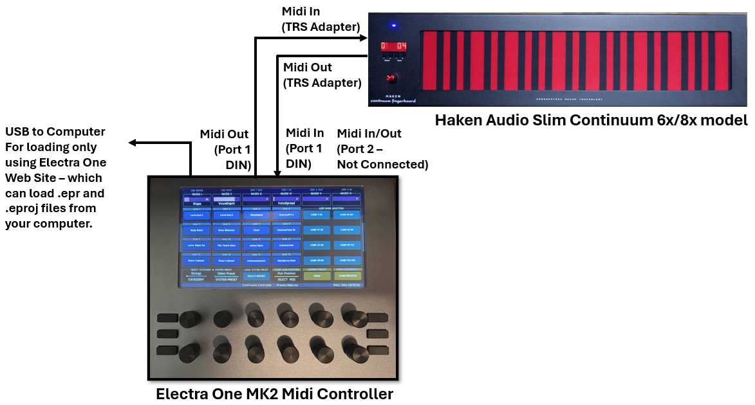

Figure 1- Connecting the Electra One to the Haken Slim Continuum

NOTE: DO NOT RUN THE EDITOR WHEN RUNNING THE ELECTRA ONE APPLICATION.

On Booting the Electra One Loaded with Continuum Controller

Do not boot the Continuum Controller if the Haken Editor is running. It is meant to operate in a stand-alone mode when the editor is not used. Connect per the diagram above and then perform the following three steps before use:

- In either order
  - Boot the Electra One loaded with the Continuum Controller.
  - Power up the connected instrument (Continuum or EaganMatrix module).
- Select the LOAD PRESETS control (see Loading Presets).
- Select the desired preset bank and preset on the Continuum Controller and then you can continue operation per this manual from there.

Electra One Controller Navigation

See the Electra One online documentation for a complete description of options. The basics for what you need to do with the Controller are summarized below.

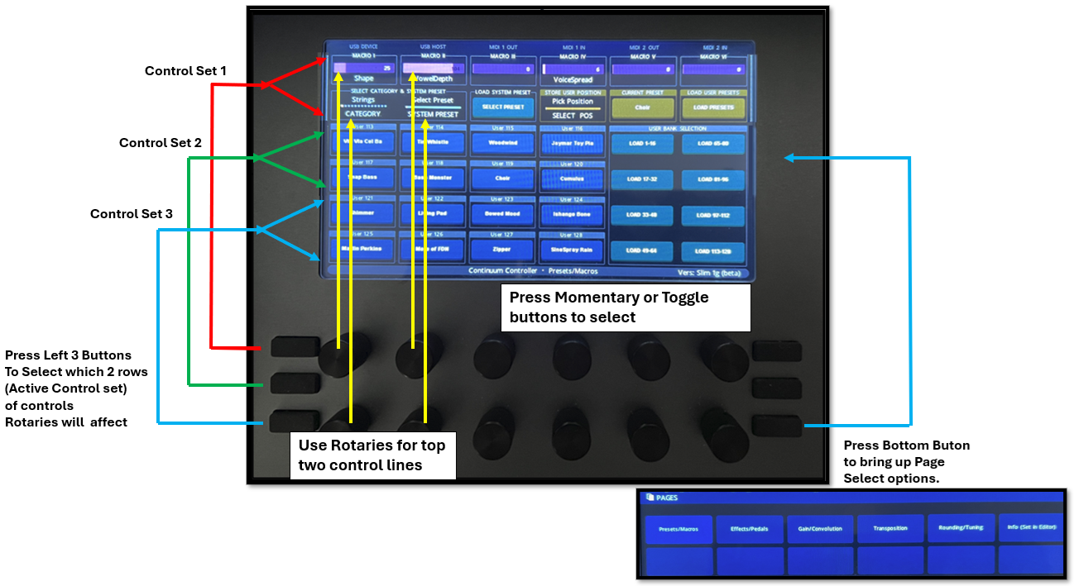

Figure 2 - Basic Electra One Navigation

Continuum Controller Pages

Six Electra One page selections are initially supported.

Press the bottom right hand button on the Electra One to bring up your page list where you can then select the desired page.

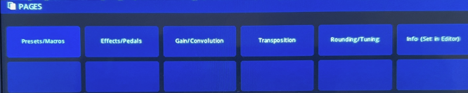

The Page name will be displayed at the bottom of the screen along with Status information (defaulting to current Continuum Controller and firmware versions).

- Main Page – Presets and Macros
  - Select any of 128 User preset in banks of 16 (like in editor)
  - Select any of the System Presets (by category with rotary)
  - Store any System Or User preset to a User preset position
  - Reload all User Presets (in case of sync issues)
  - Display Macros with their programmed names and change values using touch screen or associated rotaries

- Effects and Pedals Page:
  - Change Recirculator settings and Recirculator type
  - Mute output in case of a increasing recirculator feedback loop
  - Change Tilt EQ Settings
  - Change Compressor / TANH Settings (depending on selection)
  - Turn Global Recirculator Off if you want to used external effects
  - Change Pedal1 and Pedal 2 Assignments
  - Change Sus, Sos1 and Sos2 Control
  - Select Mono Mode and Interval

- Gain / Convolution Page
  - Change Pre and Post Master Section Gain
  - Change Attenuation
  - Change Convolution IRs and associated Convolution parameters

- Transposition Page
  - Select Any transposition in semitone increment up and down through an Octave
  - Select Octave Transpositions
  - Set Otave Switching functions
  - Change Surface Direction

- Rounding and Tuning
  - Set all rounding options
  - Set Fine Tuning
  - Set Equal Temperament or Select a Tuning Grid
  - Select Just tunings
  - Select an Equal Division of the Octave option

- Info Page and Ancillary Controls
  - Set Replace/Preserve Options
  - Display MPE information
  - Display Firmware Version
  - Display DSP Polyphony
  - Other Functions TB

Main Performance – Presets and Macros Page

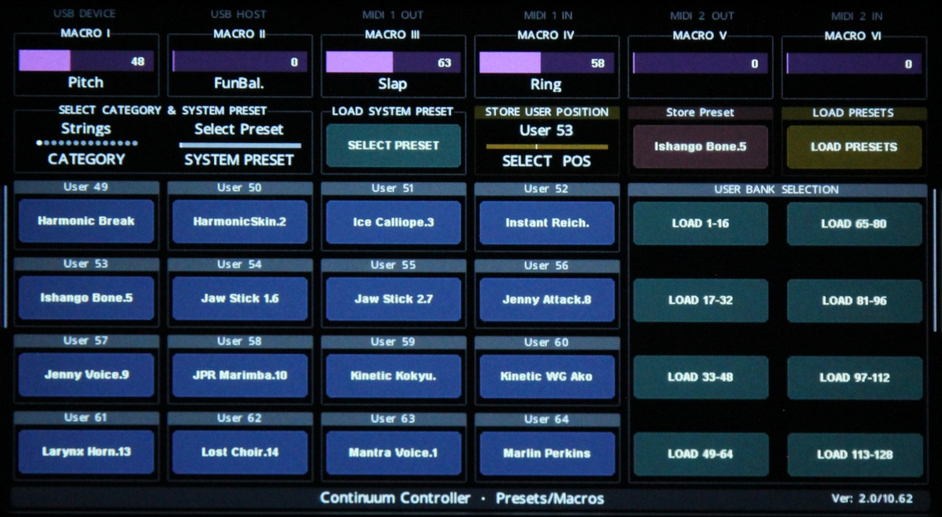

On the Main Performance – Presets and Macros page (usage diagram below) you can perform the following operations:

- View and select any one of the 128 user presets using a bank selection control. Presets are arranged 1-128 in banks of 16 presets as in the editor.
- Once a preset has been selected, its macros are displayed with the associated programmed names and current values. For now, values are in Midi units 0..127. Chance macro values with touch or with the associated group buttons and rotaries.
- You can also load any of the system presets by category and store that to a user position if desired.
- You can also store one user position to another user position to another. Note to store a preset to a user position you Select a user position and Store Preset mode is activate. Click the preset there to save to a user position. Editor-like “.position” will be appended to the name, though it may be shown truncated: see Selecting Presets.
- Finally you can reload all User presets if something goes wrong.

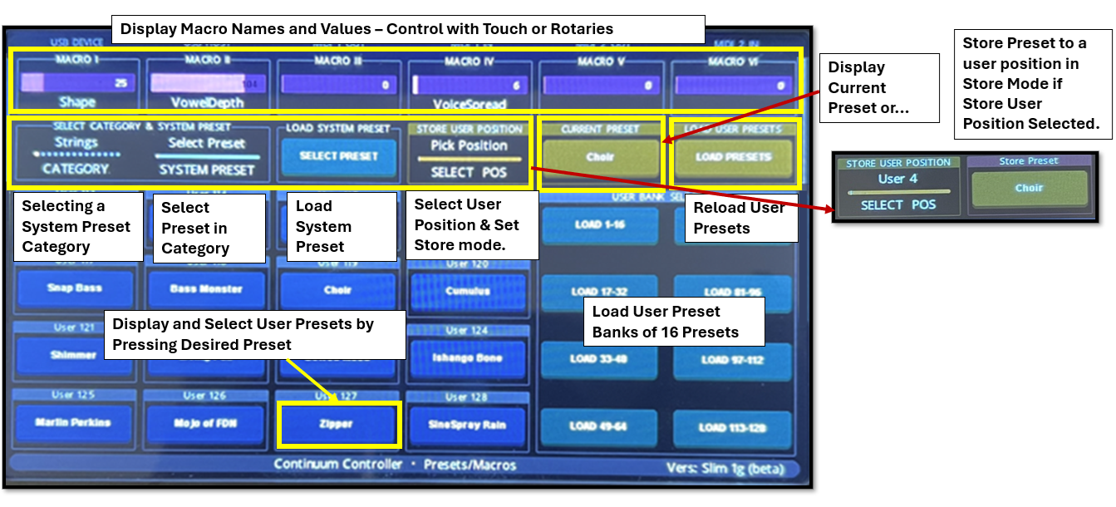

Figure 3- Electra One Controller Main Performance - Preset & Macros Page

Loading Presets

On loading Continuum Controller on the Electra One, the Load Presets control is what the Electra One documentation calls Red but looks more Burgandy:
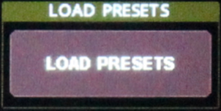
And the information message bottom right on the status bar says "Press Load Presets"
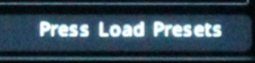

Once Continuum Controller has loaded the Continuum/EMM is connected, you must select Load presets.
- Automatically receiving preset lists from the instrument on loading Continuum Controller is no longer supported. as this could cause some Electra Ones to get stuck on the splash screen, preventing Continuum Controller's load from completing.

When the Load Preset control is selected
  - User presets will be synced
  - System presets will be synced
    - If this is the first time Continuum Controller has been used
    - Or the connected instrument's firmware version has changed
    - Or the hardware type of the connected instrument has changed, e.g. from a Continuum to an EaganMatrix module or the converse.

While presets are being synced
- The information message bottom right on the status bar will show "Getting presets…".
- The connected instrument will show "Wait".

Once presets have been synced:
- The connected instrument will show the current preset.
- The Load Presets control will be what the Electra One documentation calls Orange but looks more Olive.
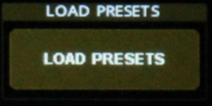
- The information message bottom right on the status bar will show the Continuum Controller version and the Haken Audio firmware version of the connected instrument.

  - Continuum Controller will be able to control the preset that is currently loaded on the instrument.

Though the Load Presets control has changed color, you can reload presets. Select the Load Presets control to reload presets:
- If your user preset list appears to be out of sync (presets don’t seem to appear in the correct slots);
- Or you have disconnected a Continuum and connected an EMM, or the converse, while Continuum Controller is running.

Selecting Presets

Note that the name length on the Electra One is limited to 14 characters, so preset names may be truncated versus the names you see if using the Haken Editor. However, for most system presets with names longer than the maximum, specified short names are substituted, avoiding truncation. For example, for "Marlin Perkins 1", "MarlinPerkins1" is shown.

User Presets

You can select a user preset by pressing one of the 16 user preset positions which are marked with preset names.

- Select one of the eight bank buttons to move through the User Preset banks for a total of 128 user presets (if they have all been loaded into user preset slots).
- Select the desired preset. The User slot of the preset appears above the preset name.
- Once selected, the preset will be loaded as the current preset and the associated macro controllers programmed for that preset will be update to reflect the correct controller names.
- The Current Preset control will display the currently loaded preset. This will not store it. You can edit it and then store it to a user position.

System Presets

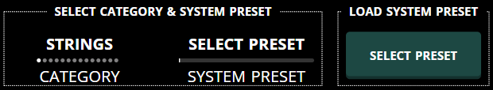

Three controls are provided to select a system preset.

- Select a Preset Category
- Select a preset in that category (the name will appear on the Load System Preset control)
- Press the Load System preset Control to load the selected preset into current preset memory. This will not store it. You can edit it and then store it to a user position.

Storing presets

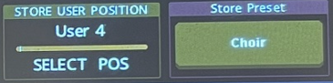

Presets can only be stored to user positions. You cannot edit and store system preset back to system preset memory. To store either a system or user preset to a user preset location:

- Press bank buttons to determine what free user position you want to store a preset to (or position you want to overwrite).
  - The position of the most recently loaded user preset, if any, will be the default. So, if you are saving system preset changes, be careful to select an empty position to avoid overwriting an existing user preset. It is highly recommended that Haken Editor be used to back up or save user presets to disc before storing presets with Continuum Controller.
- User the Store User Position control so select the desired user position. The “Current Preset” header on the Current preset control will change to “Store Preset”, if it is not already. Press the control to store to the indicated user position.
- Control values can be accidentally changed by turning the wrong rotaries. In that case simply load your desired preset again. But remember loading a preset will erase any current modifications you have made so if you want to store a preset and you think something is wrong, press the store button and you can then reload it to restore macro settings.
- Press the “Store Preset” control to store to the selected user position. Currently the Continuum Controller does not append a “.n” suffix as the editor does. If you store a user preset that has a “.n” suffix, it will be removed. You can thus have multiple presets with the same name if you store them repeatedly.
  - Once the instrument (Continuum/EMM) has stored the preset, user presets will automatically be refreshed from the instrument.
- Note: The instrument will display “Wait” on its display screen as the preset is being stored and user presets are being sent. Wait until the instrument displays the current preset number you just selected before continuing (either playing the instrument or using the Electra One controller).

Storing Your Own Presets

You can create and load your own presets with the EaganMatrix editor into User positions and then after exiting the editor you can use the Electra One Continuum Controller to select and play them along with other System and User presets you have stored.

Note: The current version of the Continuum Controller assumes preset have a “A=Name” author Edit String or “C=Codes” Character string at the end of Macro definitions to properly parse the last Macro string and display it in the macro controls. If you are creating presets or importing them from other sources, please make sure after the last Macro define there is a space and then an author or character string.

Here is a system preset with a Character string containing seven character codes follows the last macro. The Author string follows that.

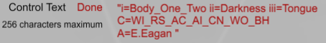

Here is a custom preset (which does not use character codes, but it has an Author code). In this case, there should be a space after the last macro string before the “A=name” author string begins.

Clearing presets

To clear a preset, simply select an empty slot marked “-“ or bring up the “Empty” preset and store that in the desired user preset position you want to clear

Effects/Pedals Page

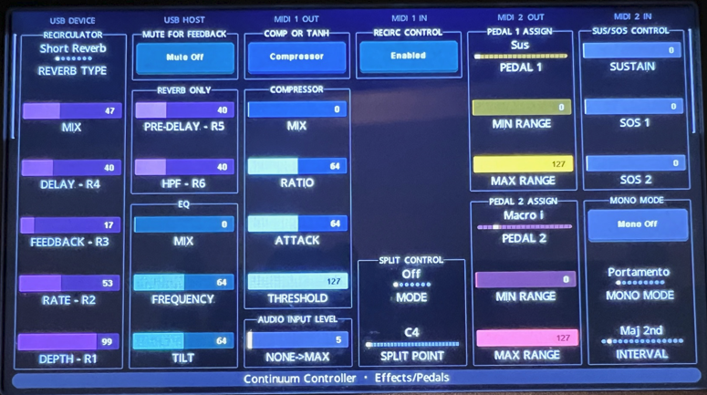

Figure 4 - Effects and Pedals Page

The Effects and Pedals page has the following controls. Save your preset to a user position to store them with any new desired settings. Except for the RECIRC CONTROL option, these settings will be lost if you change the current preset they are being applied to without it being stored to a user position.

- Recirculator Type: Changes the Recirculator settings to one of the reverb or delay options:
  - Short Reverb
  - Long Reverb (new type post 10.09 firmware)
  - Modulated Delay
  - Swept Echo
  - Analog Echo
  - Digital Delay with Low Pass Filter
  - Digital Delay with High Pass Filter

- Recirculator Controls: Once a preset is selected, these controls should display the current setting of the six possible controls that map to R1..R6 (note R5 and R6 are new in post 10.09 firmware and only apply to the two reverbs). The control names are fixed in the Continuum Controller display (Mix, Delay (time), Feedback, Rate and Depth). These change names when using the editor for some of the Recirculator options.

- Mute Button: This is provided for safety in case you set a reverb or delay with a feedback that is too high and you start to get an overpowering feedback output allowing you to bring down the feedback level and then unmute. Quickly changing presets will also stop a feedback loop.

- Mute will automatically be turned off when another preset is loaded.

- Tilt EQ Controls: You can change the three Tilt EQ settings that should be displayed with the value set in the current preset (Mix, Frequency and Tilt)

- Comp or TANH Control: This button switches between applying the Master Section Compressor or new TANH (soft clipping) function. The associated values for each will display depending on whether you have the Compressor or TANH option selected.

- Audio Input Level: This controls the Audio input level if you have a Continuum (or EaganMatrix module once that is supported). If you have a preset (primarily Processor category presets) that operates on incoming audio, make sure you bring up this level if you hear no expected sound.

- Recirc Control: This will turn the recirculator off. Make your output totally dry (though it does not affect any programmed delays that might be used in your current preset). This is the same as using the similar function in the Editor’s “Midi and Globals” page. This will disable the recirculator until it is reenabled with this control or with the similar control in the editor. If you load a preset and it is totally dry and you can’t seem to apply reverb or delay, make sure this control is not set to recirculator off.

- Pedal 1 Control: This lets you set the Pedal 1 Assignments as you can in the editor
  - Pedal function (Sus, Sos1, Sos2, Macros i..vi, Post-gain, Pre-gain, Oct switch, Mono Switch, Round Rate, Round Initial, Oct Stretch, Fine Tune, User Advance)
  - Min Pedal Range
  - Max Pedal Range
- Pedal 2 Control: Same assignments as for Pedal 1

- Sus/Sos Control: Allows you to manually set Sustain and Sostenuto 1&2 functions manually with a control instead of using the pedal.

- Mono Mod Options:

  - Mono Mode Control: Switched Mono mode on and off (unless you are set Polyphony 1 in which case mono mode will be automatically applied).
  - Set Mono Mode: Lets you select the desired Mono mode:
    - Pressure weighted Portamento (default)
    - Legato Z (Legato to Highest Pressure Finger)
    - Retrig Z (Retrigger on Highest Pressure)
    - Leg New T (Legato to New Touch)
    - Retrig T (Retrigger at new Touch)
    - Touch & Lift (Retrigger at Touch and Lift
    - Leg T Max Z (Legato to new Touch, Use Max Z)
    - Retrig TZ (Retrigger at New touch, Use Max Z)
    - Retrig TLZ (Retrigger Touch and Lift, Use Max Z)
  - Set Mono Interval
    - Set in half step increments though the Octave

    - 2 Octave, 3 Octaves and Max Range (Full fingerboard range)

Gain and Convolution Page

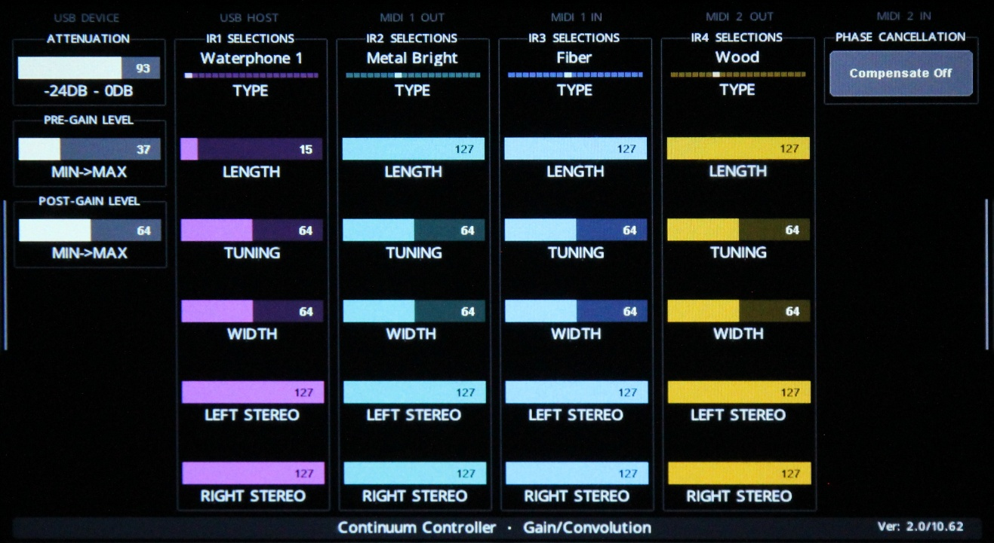

Figure 5 - Gain and Convolution Page

The Gain and Convolution page lets you adjust gain levels and change convolution settings. These will not be saved unless you store the preset you change to a user position. Gain settings need not be on the main page for a Slim Continuum as it has an attenuation knob that can quickly and easily be adjusted. When loading a preset, its current gain and convolution parameters should be displayed and you can adjust them from that point. Convolution adjustments are not intended to be done while performing and they send data to the Continuum that will produce audio discontinuities.

The page includes:

- Gain & Attenuation Settings
  - Pre Master Section Gain: Use this to induce saturation effects and adjust pre gain as desired
  - Post Master Section Gain:

- Convolution settings: For each of the four Impulse Responses (IR1 to IR4).
  - IR type: You can select the type of IR for each of the four IRs. Note that the indexing between them will be up to how the preset is programmed. You may hear no change for example if the preset is only programmed to index between the first two IRs and you change IR3 or IR4. Note that a number of new IRs have been added post 10.09 firmware.
    - Waterphone 1
    - Waterphone 2
    - Autoharp 1
    - Autoharp 2
    - Guitar Dark
    - Finger Snap
    - Wood
    - Metalbright
    - Fiber
    - Leather
    - Metal Damped
    - Nylon
    - Cloth
    - EOWave Gong
    - LVDL Pyramid (La Voix du Luthier)
    - LVDL Gong Snap
    - LVDL Onde
    - White
    - Gray

- Phase Cancellation Compensation Please refer to the Continuum User's Guide for details.
- Phase Cancellation Compensation is shown as Ep in the Haken Editor.

Note: Convolution is programmed. Convolution Mix and Index are usually controlled by macro controllers programmed into a preset. Look for them as well when you alter convolution settings here.

Transposition Page

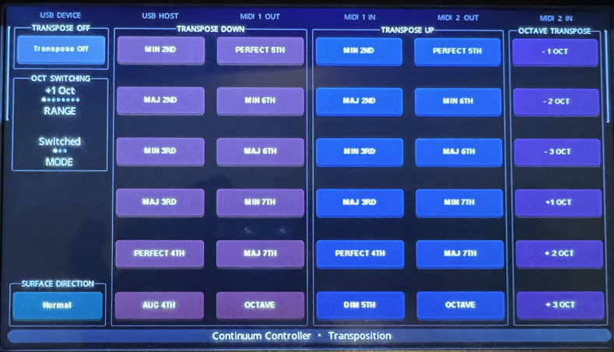

Figure 6 - Transposition Page

The transposition page provides an easy way to transpose up and down through the octave by semitone as well as a number of octave transpositions. A few other controls are included.

Note: Transpositions alter the “middle C” parameter that is set per preset. If you want to set a transposition to apply to all presets loaded, set the Preserve option for now in the editor in the “Midi and Globals” page.

- Transpose Down, Up or By Octave. Simply press the designed option. The Transpose control at the top left will change to indicate how many semitones of transposition have been selected

- Transpose Off: If a transposition has been selected, this control turns off transposition and resets middle C to note=60 (default).

- Oct Switching: These control set the Octave switching parameters – that are typically set using a pedal set to Oct Switch option.
  - Range: Set the Octave switch range up and down through four octaves (+1 octave is the default)
  - Switch Mode: Sets one of three octave switching modes:
    - Switched (default)
    - Toggle

    - Instant

- Surface Direction: reverse the playing direction on the fingerboard. A line moving up will actually move in the opposite direction down and vice versa.

Rounding and Tuning Page

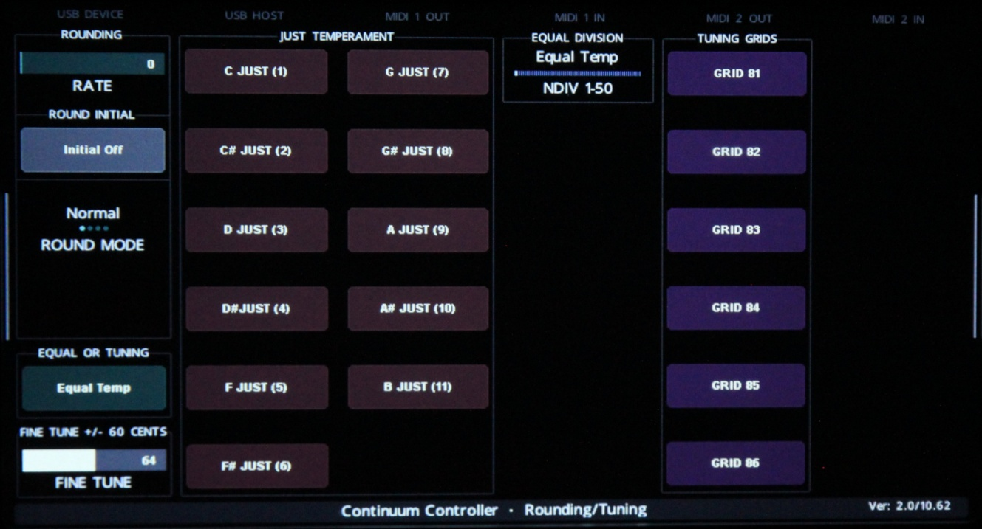

Figure 7 - Rounding and Tuning Page

The Rounding and Tuning page allows the user to set Continuum Rounding, Tuning and customer Tuning Grid selection.

- Rounding: Includes the standard three rounding controls:
  - Round Rate: Sets the Rounding rate from 0 (no rounding) to max (full rounding – quantized by half step).
  - Round Initial: Turn initial rounding on or Off
  - Round Mode: Sets the rounding mode
    - Normal (Round during entire note using Round Rate)
    - Release (Round only after finger lifted on release)
    - Via Y (Always round at Y=0, gradual transition to no rounding at Y=1)
    - Via -Y (Always Round at Y=1, gradual Transition to no rounding at Y=0)

- EQUAL or TUNING: This control returns to Equal temperament if you had selected one of the other tuning options.

- Fine Tune: Adjust fine tuning up and down +/- 60 cents.

- Just Tuning: These options easily select one of the 12 Just temperament options. If selected the EQUAL or TUNING control will display the current tuning. Pressing that control to return to Equal Temperament.

- EQUAL DIVISION: This will set one of the Equal Division tuning options. (Not currently not supported)

- Tuning Grids: This will select one of the tuning grids assuming it has been loaded with the appropriate tuning tables using the Pitch Table Editor (PTE). See PTE documentation available from Haken Audio for further information. If selected the EQUAL or TUNING control will display the current tuning. Pressing that control to return to Equal Temperament.

Info Page

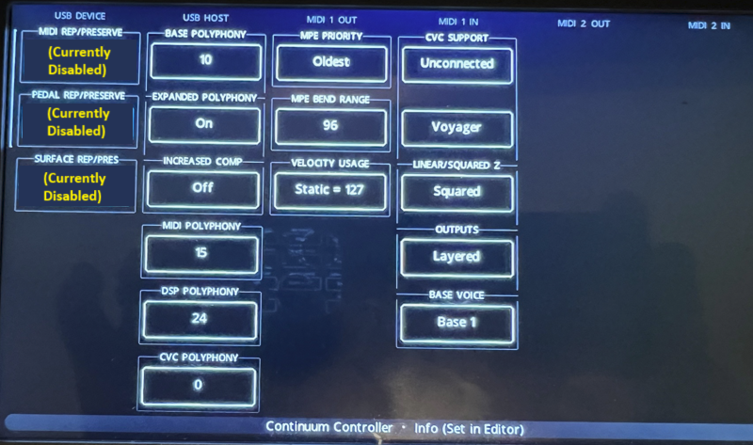

Figure 8 - Info Page

The Info page displays system configuration data. It also will allow setting Preserve/Replace options, but currently those are disabled and you should go into the Editor in “Midi and Global Settings” to set these options.

Info display options include :

- Base MPE Polyphony
- Expanded Polyphony
- Increase Computation
- Midi Polyphony
- DSP Polyphony
- CVC Polyphony (if CVC is connected)
- MPE Priority
- MPE Bend Range
- Velocity mode
- CVC configuration

Note: If you need to set any of these parameters, for now, you must use the Haken editor. If you bring up the editor, it may not connect if the Electra One is connected to your computer and you have the Electra One Web site open. Never try and run the Electra One Continuum Controller if you are connected to the editor. Unpredictable operation can result on both.

Installing the Continuum Controller Application

Go the Electra One website's App & Presets section at https://app.electra.one/ and log into you account, if you have not already. Once you have logged in, go to the Preset Library page.

On the Preset Library page, filter for brand Haken or search for Continuum Controller. You can then send Continuum Controller to your Electra One controller.

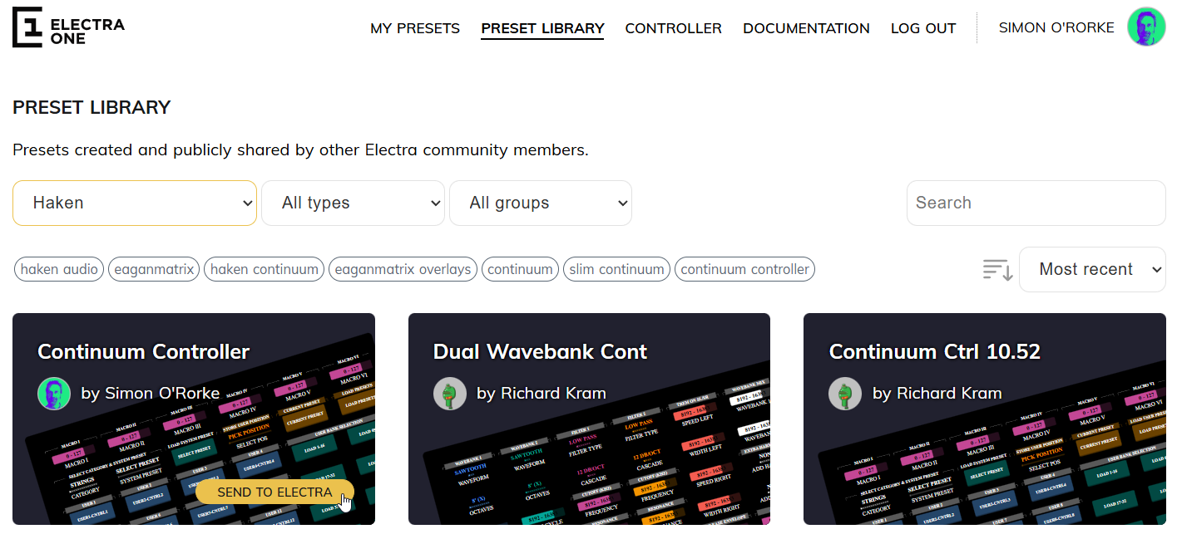

Figure 9 - Loading from Preset Library

- To find other Electra One presets available for Haken Audio instruments, filter Electra One's Preset library on brand Haken.

When to use the Haken Editor

As noted earlier, you should never operate the Haken Editor while using the Electra One Continuum Controller. You can leave the Electra One connected to the Continuum, but don’t operate it while the editor is open. Once you close out the editor, its advised to repower the Electra one to bring it up in its initialized state and then select a preset as you would normally use it. Another thing to try after closing out the editor is simply reloading the User presets.

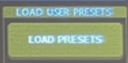

Editor Specific Operations

The editor still is required for the following operations:

- Programming presets – creating or modifying existing EaganMatrix presets
- Quickly moving files to user positions and loading customer files either created by yourself or others into user positions. The Continuum Controller is intended a stand-alone controller and does not have an interface to your computer for loading and saving files on your computer.
- Saving and Loading Group Files
- Saving and Loading presets for backup purposes to your computer’s disk or external hard drive
- Setting MPE Parameters for a preset (Polyphony, Priority, Bend, etc.). This may be added to a future release of the Continuum Controller.
- Setting Preserve and Replace states for Midi, Pedal and Surface in Midi and Global Settings
- Setting CVC options if you have a CVC connected
- Change Continuum Midi routing
- Changing AES settings

Support and Feedback

Please post suggestions, support questions and issues and to Continuum Controller's Electra One Forum topic https://forum.electra.one/t/continuum-controller.

You are also welcome to discuss Continuum Controller in the Haken Continuum Users group on Facebook. However, to ensure a response from the developers, you should post to the Electra One Forum topic.

Continuum Controller is not a Haken Audio product. Please do not raise Haken Audio tickets.

